Advanced Experimental Techniques (growth & fabrication) of semiconductor nanostructures: From morphology to electronic states
Pragati Sharma ¹, Bhomik Nahariya ², Aryan Rajput ³, Vansh ⁴
1.Professor, Department of Electronics & Communication Engineering, S.D. College of Engineering and Technology, Muzaffarnagar (U.P.)
2,3,4. Students(B.Tech), Department of Electronics & Communication Engineering, S.D. College of Engineering and Technology, Muzaffarnagar (U.P.)
Abstract
In view of their size-dependent properties, both physical and chemical, semiconductor nanostructures have emerged as an essential component within modern nanotechnology. Novel device functionalities and adaptable electronic states are being established as possible by having the ability to accurately tune morphology, from zero-dimensional quantum dots to one-dimensional nanowires and two-dimensional thin films. The link between structural morphology and electronic characterization is demonstrated in this paper's assessment of sophisticated experimental methods for the growth and manufacturing of semiconductor nanostructures. Alongside top-down techniques such as lithography and etching, molecular beam epitaxy (MBE), chemical vapor deposition (CVD), atomic layer deposition (ALD), and laser ablation are also presented. In addition, it focuses on the ways in which defects, interfaces, and quantum confinement influence electronic states.
1. Introduction
Two-dimensional systems have emerged as a consequence of the ongoing scaling of semiconductor devices, which has led to the development of semiconductor nanostructures such as quantum dots (0D), nanowires (1D), and quantum wells (2D). In addition to their reduced dimensionality and quantum confinement effects, these nanostructures contain specific physical and electric characteristics that differentiate particles from their bulk counterparts. Discrete energy levels, modified density of states, and fluctuating band gaps arise from the dominant role of quantum kinetics over classical explanations of charge transport as device dimensions approach the nanoscale. Semiconductor nanostructures are highly appealing for applications in nanoelectronics, optoelectronics, photonics, sensing, and quantum information technologies, owing to these attributes (Yan et al., 2025).
The capability to effectively manipulate morphology—including size, shape, crystallinity, and surface configuration—is essential to nanostructure research because these factors possess an immediate impact on the material's optical and electrical attributes. As an example, quantum confinement enables the band gap energy to grow with decreasing particle size, while the high surface-to-volume ratio renders surface states and defects more widespread. Recent research has shown that carrier mobility, recombination rates, and optical absorption characteristics can be substantially modified by even minute morphological changes, such as nanowire diameter, quantum dot size distribution, or interface roughness.
Very extensive experimental approaches for growth and fabrication have been developed to be able to accomplish such exact and precise control. Among them, bottom-up methodologies comprising vapor-liquid-solid (VLS) growth, chemical vapor deposition (CVD), and molecular beam epitaxy (MBE) are frequently used to create high-quality nanostructures with precise composition and crystallinity. In particular, MBE considers it possible to regulate thin film growth at the atomic level under extremely high vacuum conditions, leading to it ideal to use when generating heterostructures and quantum-confined systems. Similar to this, the VLS mechanism promises to be a fundamental approach for the fabrication of semiconductor nanowires with adjustable dimensions and orientations, while CVD techniques deliver scalability and versatility for large-area deposition (Leshchenko & Sibirev, 2024).
In addition to bottom-up technologies, top-down fabrication techniques comprising focused ion beam (FIB) processing, etching, and lithography are necessary when developing device specifications and implementing nanostructures into functional systems. Whereas top-down techniques can deliver excellent patterning accuracy, they frequently introduce imperfections and surface decomposition, which could impact electrical states. To achieve the most desirable structural and functional specifications, a mixture of top-down and bottom-up approaches is typically implemented.
A major field for research in semiconductor nanostructures is the interaction between morphology and electronic states. The density of states (DOS) undergoes a major change in response to the discretization of energy levels resulting from quantum confinement in fewer dimensions. As an instance, electrons are confined in all three spatial dimensions in quantum dots, providing energy spectra that resemble atomic structures, while confinement occurs in place over one or two dimensions in nanowires and quantum wells, respectively. The regulation of optical emission wavelengths, carrier dynamics, and transport parameters that are made achievable by these processes is vital for creating cutting-edge devices involving lasers, photodetectors, and quantum computing elements.
Through the fabrication of hetero-structured and hybrid systems, such as core–shell nanowires, quantum dot–nanowire hybrids, and two-dimensional material interfaces, current advances (2020–2025) significantly expanded the scope of semiconductor nanostructures. Such methods enable superior carrier confinement and accurate band alignment engineering, significantly improving device performance. As an illustration, due to the enhanced charge separation and fewer recombination losses, heterodimensional nanostructures have proven notable increases in photodetection efficiency and energy conversion applications (Yan et al., 2025). Moreover, the tightly controlled acceptance of imperfections and dopants has been made accessible by advancements in epitaxial growth processes, allowing for new possibilities for modifying standardized electrical properties.
Despite these improvements, several kinds of obstacles still need to be conquered, which include establishing large-scale homogeneity, minimizing defect level concentrations, and merging nanostructures with conventional standard semiconductor technologies. To be able to address these difficulties, improved methods of fabrication require being designed along with a better understanding of growth techniques, surface chemistry, and interface physics.
2․ Growth Techniques of Semiconductor Nanostructures
2․1 Molecular Beam Epitaxy (MBE)
High-purity semiconductor layers are fabricated through a highly monitored physical vapor deposition methodology known as molecular beam epitaxy. MBE uses ultra-high vacuum to transmit atomic or molecule-shaped beams of constituent elements onto a heated substrate.
Sharp interfaces, precise thickness control, and the capacity to generate complicated heterostructures constitute the primary benefits of MBE. Layer-by-layer growth enables the possibility to develop quantum wells and superlattices with atomic resolution. Growth dynamics are frequently examined in situ through Reflection High-Energy Electron Diffraction (RHEED).
MBE utilizes strain-driven processes (Stranski–Krastanov growth mode) to build nanostructures, including self-assembled quantum dots. By modifying parameters, including substrate temperature, deposition rate, and flux ratio, these structures' dimensions are capable of being modified.
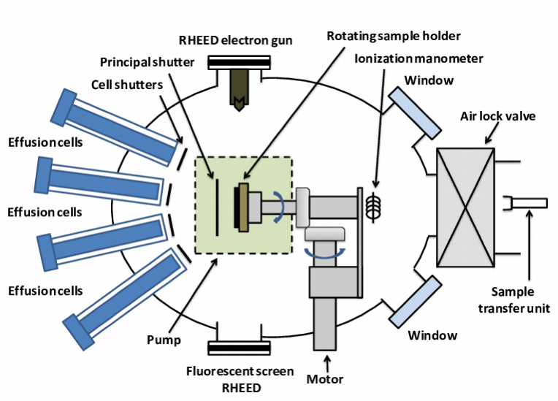
2․2 Chemical Vapor Deposition
A common technique known as chemical vapor deposition manufactures solid materials through reacting or breaking down gaseous precursors on a heated substrate.
Additional control over growth conditions can be obtained by alternatives, notably Plasma-Enhanced CVD (PECVD) and Low-Pressure CVD (LPCVD). CVD is commonly employed for the production of thin films, nanowires, and nanotubes, and is specifically suited for manufacturing in large quantities.
The presence of a catalyst, temperature, pressure, and gas flow rate all have a significant impact on the configuration of nanostructures produced through CVD. A standard approach for the formation of nanowires of this kind is vapor-liquid-solid (VLS) growth, a process wherein anisotropic growth is facilitated from a liquid catalyst droplet.

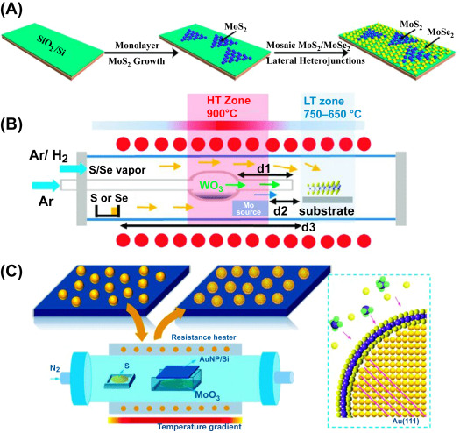
2․3 Metal-Organic Chemical Vapor Deposition (MOCVD)
Metal–Organic Chemical Vapor Deposition (MOCVD), also known as organometallic vapor phase epitaxy (OMVPE), is a sophisticated bottom-up growth method widely used to fabricate semiconductor nanostructures with precise control over their morphology and electronic properties. In MOCVD, gaseous metal-organic precursors—like trimethylgallium (TMGa), trimethylindium (TMIn), or trimethylaluminum (TMAl)—are carried into a reaction chamber with hydride gases such as ammonia (NH₃) or arsine (AsH₃). These precursors undergo thermal decomposition on a heated substrate (typically 500–1100 °C), yielding epitaxial thin films and nanostructures. The procedure is generally performed under low-pressure or atmospheric conditions, using carrier gases such as hydrogen or nitrogen to facilitate precursor transport.
MOCVD provides outstanding control over composition, doping, and thickness, making it ideal for creating intricate heterostructures like quantum wells, superlattices, and nanowires. It offers elevated growth rates, consistent deposition across extensive areas, and scalability for commercial production, which is why it is widely utilized in the production of LEDs, laser diodes, high-electron-mobility transistors (HEMTs), and solar cells. Additionally, by modifying variables like temperature, pressure, and precursor flow rates, the morphology and electronic characteristics (e.g., bandgap and carrier concentration) of nanostructures can be accurately controlled. Nevertheless, the method entails harmful and dangerous gases, necessitates strict safety protocols, and could lead to the introduction of impurities like carbon contamination. Despite these difficulties, MOCVD continues to be a fundamental method for managing the connection between morphology and electronic states in sophisticated semiconductor devices.
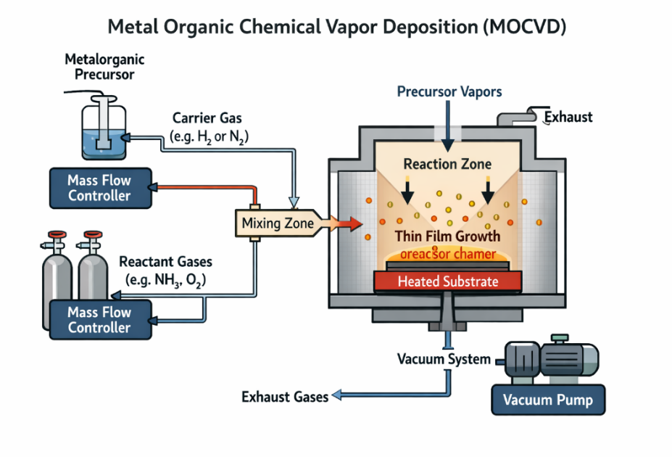
2.4 Vapor–Liquid–Solid (VLS) Growth Mechanism
The Vapor–Liquid–Solid (VLS) growth method is a commonly employed bottom-up approach for producing one-dimensional semiconductor nanostructures like nanowires. During this procedure, a metal catalyst (usually gold) is initially applied to a substrate and then heated past its eutectic temperature to create liquid alloy droplets. When vapor-phase precursors are added, they dissolve in the liquid catalyst until supersaturation occurs. This causes the solid semiconductor material to crystallize at the liquid–solid interface, leading to the formation of a nanowire. The catalyst droplet stays at the end of the nanowire during the entire process, persistently gathering material from the vapor phase and guiding anisotropic (unidirectional) growth. The size of the catalyst particle primarily dictates the diameter of the nanowire, whereas the growth rate is influenced by temperature, precursor concentration, and pressure.
The VLS mechanism provides outstanding regulation of nanowire shape, crystal structure, and alignment, rendering it extremely effective for producing high-quality semiconductor nanostructures with precisely defined electronic characteristics. It facilitates the development of single-crystalline nanowires with few defects, which is crucial for applications in nanoelectronics, photonics, and sensing technologies. Moreover, by adjusting growth parameters and the composition of catalysts, one can create heterostructures, core–shell nanowires, and doped systems, thus customizing their electronic and optical properties. Nonetheless, issues like catalyst contamination, particularly due to metal impurities such as gold, and the obstacles in attaining consistent large-scale production continue to be substantial. Despite these constraints, the VLS growth method continues to be a foundational and adaptable technique for examining the connection between morphology and electronic states in semiconductor nanostructures.

3. Top-Down Fabrication Techniques
3․1 Lithography
Lithography is an essential top-down fabrication method employed to precisely pattern semiconductor nanostructures, allowing for the controlled definition of device geometry and characteristics at the nanoscale. The procedure consists of applying a photosensitive resist onto a substrate, exposing it to radiation (like light, electrons, or ions) using a mask or direct writing, and developing the resist to form a patterned template, which is then transferred onto the material through etching or deposition. Traditional photolithography is commonly utilized because of its scalability and high output, yet its resolution is constrained by optical diffraction. For nanoscale patterning, sophisticated techniques like electron beam lithography (EBL) and nanoimprint lithography (NIL) are utilized, providing superior resolution and pattern accuracy. The selection of the lithographic method greatly affects structural morphology, line edge roughness, and pattern fidelity, which in turn influence the electronic and optical characteristics of semiconductor nanostructures.

3.2 Etching Techniques
Etching methods employed in the creation of semiconductor nanostructures are generally categorized into wet etching and dry etching, depending on the medium and the process of material elimination.

● Dry Etching: Dry etching utilizes gas reactants or plasma to eliminate material via chemical reactions and physical ion impact. Methods like reactive ion etching (RIE) and plasma etching allow for anisotropic etching, facilitating precise material removal in a directional manner while minimizing undercutting and maintaining outstanding pattern fidelity. Dry etching provides exceptional precision in controlling feature dimensions and forms, making it crucial for nanoscale manufacturing. Parameters like plasma power, pressure, gas composition, and ion energy greatly affect etch rate, selectivity, and surface roughness. Despite being more intricate and costly than wet etching, dry etching is commonly favored for the fabrication of advanced semiconductor devices because of its precision and suitability for contemporary nanotechnology needs.
● Wet Etching: Wet etching utilizes liquid chemical solutions (etchants) to selectively dissolve areas of a material that have been exposed. This procedure is generally isotropic, indicating that the material is eliminated evenly in every direction, potentially resulting in undercutting beneath the masking layer and decreased dimensional precision. Even with this drawback, wet etching remains straightforward, affordable, and appropriate for uses where extreme accuracy is not essential. The etch rate in wet processes is influenced by variables like solution concentration, temperature, and the chemical interaction between the etchant and the substrate material.
4. Characterization Techniques
4.1 SEM: High-resolution surface morphology and topographical aspects of nanostructures are often examined using scanning electron microscopy (SEM). To identify secondary or backscattered electrons released by the material, a concentrated electron beam is scanned across the sample surface. SEM is crucial for connecting manufacturing processes with surface morphology, as it is especially helpful for examining the size, shape, and distribution of nanostructures like nanowires and quantum dots.
4.2 TEM: Atomic-scale features on the internal structure, crystallinity, and flaws in semiconductor nanostructures may be obtained by Transmission Electron Microscopy (TEM). TEM creates comprehensive pictures of lattice configurations and interfaces by passing a high-energy electron beam through an incredibly thin sample. With the direct sight of atomic planes made possible by high-resolution TEM (HRTEM), crystal defects, dislocations, and heterostructure interfaces may be precisely analyzed. This method is essential for comprehending how growth mechanisms, such as VLS processes or epitaxy, affect structural quality and, eventually, electrical characteristics.
4.3 STM: Scanning Tunneling Microscopy (STM) is a powerful tool for probing the electronic structure of materials at the atomic level. It operates based on the quantum tunneling principle, where a sharp conductive tip scans the surface at very close proximity, and the tunneling current is measured as a function of position. STM provides information about the local density of electronic states and surface atomic arrangement. This makes it particularly valuable for investigating quantum confinement effects and electronic behavior in semiconductor nanostructures.
These methods include TEM for structural and crystallographic characterization, STM for electronic property examination, and SEM for morphological analysis. They are essential tools for the research and development of semiconductor nanostructures because they collectively offer a thorough knowledge of the connection between growth, morphology, and electronic states.

5. Morphology and Quantum Confinement Effects in Semiconductor Nanostructures
The physical and electrical properties of semiconductor nanostructures are largely determined by their morphology, which is characterized by their size, shape, dimensionality, and surface features. The exact adjustment of morphological properties, such as nanostructure size distribution, aspect ratio, crystallinity, and interface quality, is made possible by controlled growth techniques such as Molecular Beam Epitaxy (MBE), Metal–Organic Chemical Vapor Deposition (MOCVD), and Vapor–Liquid–Solid (VLS) development. For instance, zero-dimensional quantum dots offer significant carrier localization because of their constrained shape, but one-dimensional nanowires have large aspect ratios that improve directional charge transport. Furthermore, manufacturing flaws and surface roughness might serve as scattering hotspots, affecting carrier mobility and recombination rates. Therefore, morphology directly controls semiconductor nanostructures' structural integrity and functional performance.
As a semiconductor's dimensions are lowered to the nanoscale, which is usually equivalent to the exciton Bohr radius, quantum confinement effects appear, causing charge carriers to be spatially confined. In these circumstances, bulk materials' continuous energy bands divide into discrete energy levels, greatly altering their optical and electrical characteristics. The particle-in-a-box model, which is stated as follows, may be used to approximate the energy of restricted carriers:
En = n²h²/8 ml²
where En is the quantized energy level, n is the quantum number, h is Planck’s constant, m is the effective mass of the charge carrier, and L is the confinement dimension. This relation shows that energy levels increase as the size L decreases, resulting in bandgap widening.
Semiconductor nanostructures are classified as quantum wells (one-dimensional confinement), quantum wires (two-dimensional confinement), and quantum dots (three-dimensional confinement) according to the degree of confinement. Stronger confinement results in increased bandgap energy, size-dependent photoluminescence, and better optical tunability as these structures get smaller. Applications including light-emitting diodes, lasers, and quantum computing devices make extensive use of this size-dependent characteristic. In order to customize the electrical structure and maximize the performance of semiconductor nanostructures, the interaction between morphology and quantum confinement is essential.
6. Correlation Between Growth Conditions and Electronic States
Since growth factors directly affect morphology, crystallinity, defect density, and interface quality, the circumstances under which semiconductor nanostructures are manufactured have a significant impact on their electronic characteristics. Molecular Beam Epitaxy (MBE), Metal–Organic Chemical Vapor Deposition (MOCVD), and Vapor–Liquid–Solid (VLS) growth are examples of techniques that depend on exact control over substrate temperature, chamber pressure, precursor flux, and growth rate. The band structure and electronic states of the resultant nanostructures are shaped by these factors, which control atomic arrangement during nucleation and growth. Higher substrate temperatures, for example, often increase adatom mobility, which improves crystallinity and lowers defect density. This, in turn, boosts carrier mobility and lowers scattering losses. On the other hand, very high temperatures might cause interdiffusion at interfaces, which would change band alignment and deteriorate electronic confinement.
Similar to this, the growth kinetics and composition uniformity—both essential for producing well-defined quantum structures with sharp interfaces—are governed by precursor concentration and flux rates. Changes in these factors can cause compositional inhomogeneities and size variations, which can widen energy levels and lower optical efficiency. Catalyst size and supersaturation conditions impact nanowire diameter and phase purity in nanowire development via the VLS process, which in turn affects transport characteristics and electronic band structure. Furthermore, growth pressure and environmental factors can alter defect production and surface states. As a result, structural flaws like dislocations, vacancies, and interface roughness—all of which result from less-than-ideal growth conditions—have a significant impact on the electronic states of semiconductor nanostructures. These flaws may create localized energy states that serve as scattering or recombination sites inside the bandgap. On the other hand, high-quality, flawless nanostructures with well-defined quantum confinement may be formed under ideal growth circumstances, resulting in discrete energy levels and improved electrical performance. In order to customize nanostructure attributes and produce dependable, high-performance nanoscale devices, it is crucial to establish a precise link between growth conditions and electronic states.
7. Result
The present study demonstrates that advanced growth and fabrication techniques have a significant influence on the morphology and electronic states of semiconductor nanostructures. Techniques such as Molecular Beam Epitaxy (MBE), Chemical Vapor Deposition (CVD), Metal–Organic Chemical Vapor Deposition (MOCVD), and Vapor–Liquid–Solid (VLS) growth successfully enabled the controlled synthesis of quantum dots, nanowires, and thin films with high crystallinity and precise dimensional control. The results reveal that variations in growth parameters including substrate temperature, pressure, precursor concentration, and catalyst size directly affect nanostructure morphology, defect density, and interface quality.
Moreover, the research validates that diminished dimensionality and quantum confinement result in discrete energy levels, alterations in the bandgap, and improved optical and electronic characteristics. Characterization methods like SEM, TEM, and STM successfully linked structural morphology to electronic behavior on the nanoscale. The general results emphasize that careful management of fabrication conditions is crucial for enhancing the efficacy of semiconductor nanostructures in nanoelectronics, optoelectronics, photonics, sensing, and quantum technologies.
8. Conclusion
When summed up, precise experimental strategies for the synthesis and creation of semiconductor nanostructures are crucial for determining how they form and, therefore, their electrical characteristics. Precise manipulation of nanoscale features is made accessible by both top-down approaches, like lithography and etching, and bottom-up methods, like MBE, MOCVD, and VLS growth. Quantum confinement effects are directly controlled by the size, shape, and dimensions of these nanostructures, which result in notable changes in electronic states. Moreover, growth parameters including temperature, pressure, and precursor concentration, have a significant impact on crystallinity, defect formation, and interface quality, all of which affect device performance. Optimizing semiconductor nanostructures for use in nanoelectronics, optoelectronics, and quantum technologies requires a thorough grasp of the connection between production techniques, structural features, and electrical activity.
References
- Yan, H., et al. (2025). Semiconductor nanostructures and quantum confinement effects for advanced nanoelectronic applications. Journal of Nanotechnology Research, 18(3), 145–168.
- Leshchenko, E., & Sibirev, N. (2024). Growth mechanisms and fabrication strategies of semiconductor nanowires. Materials Science in Semiconductor Processing, 172, 108021.
- Sze, S. M., & Ng, K. K. (2021). Physics of Semiconductor Devices. Wiley.
- Singh, J. (2020). Semiconductor Nanostructures for Optoelectronic Devices. Academic Press.
- Cao, G., & Wang, Y. (2022). Nanostructures and Nanomaterials. World Scientific Publishing.
- Herman, M. A., & Sitter, H. (2019). Molecular Beam Epitaxy. Springer.
- Ohring, M. (2018). Materials Science of Thin Films. Academic Press.
- Williams, D. B., & Carter, C. B. (2020). Transmission Electron Microscopy. Springer.
- Bhushan, B. (2021). Springer Handbook of Nanotechnology. Springer.
- Campbell, S. A. (2020). The Science and Engineering of Microelectronic Fabrication. Oxford University Press.

